**Adding a Relying Party in ADFS 3.0**

**Prerequisites**

* Note that followings are the key information should be provided by the application owner.

|  |  |
| --- | --- |
| Client_id | LCjusy5ajAoqF87j3cqc765bPkAa |
| Client_id redirect URL | <https://api.oasys.lk:9843/carbon> |
| Commonauth endpoint | <https://api.oasys.lk:9843/commonauth> |
| Relying party trust identifier | WSO2IDSNDBOASYSLIVE |
| Certificate | Wso2 IDS certificate (.crt) |

* Below information should be provided by ADFS owner

|  |  |
| --- | --- |
| Trusted URL | Ex : https://<AD_FS_server>/adfs/ls |
| Metadata URL | Ex: http://<AD_FS_server>/adfs/services/trust |

**Steps**

In ADFS Management UI expand Trust Relationship, right click on Relying Party Trust and select Add Relying Party Trust…

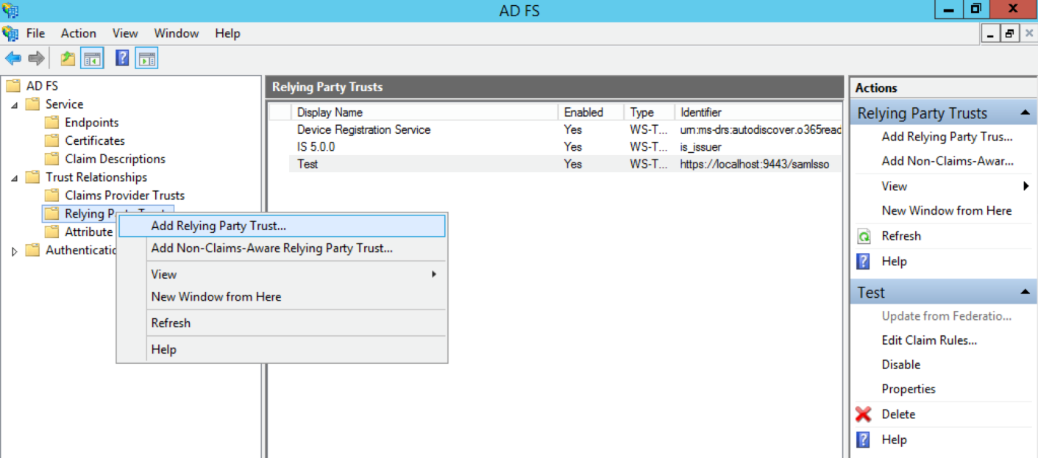

Follow the wizard as shown below

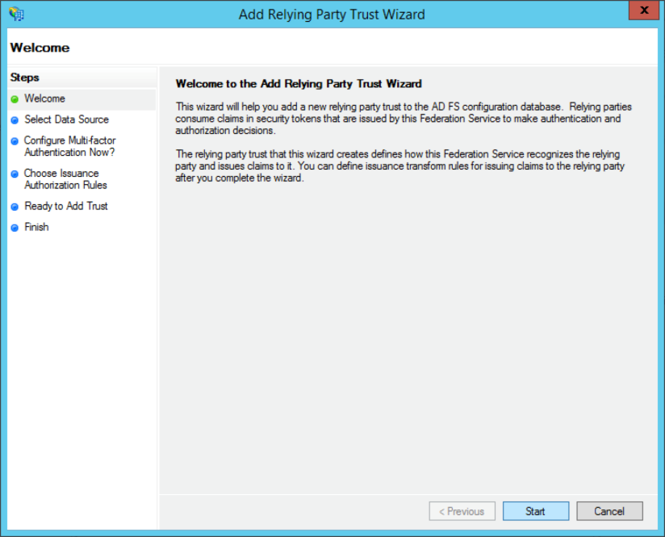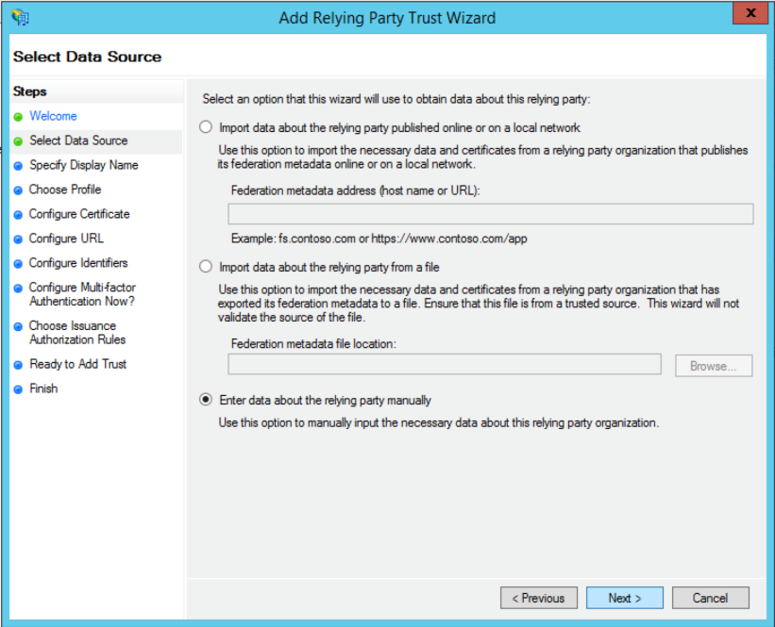

Type a desired display name (wso2km21AzureLive) for the relying party and click **Next**

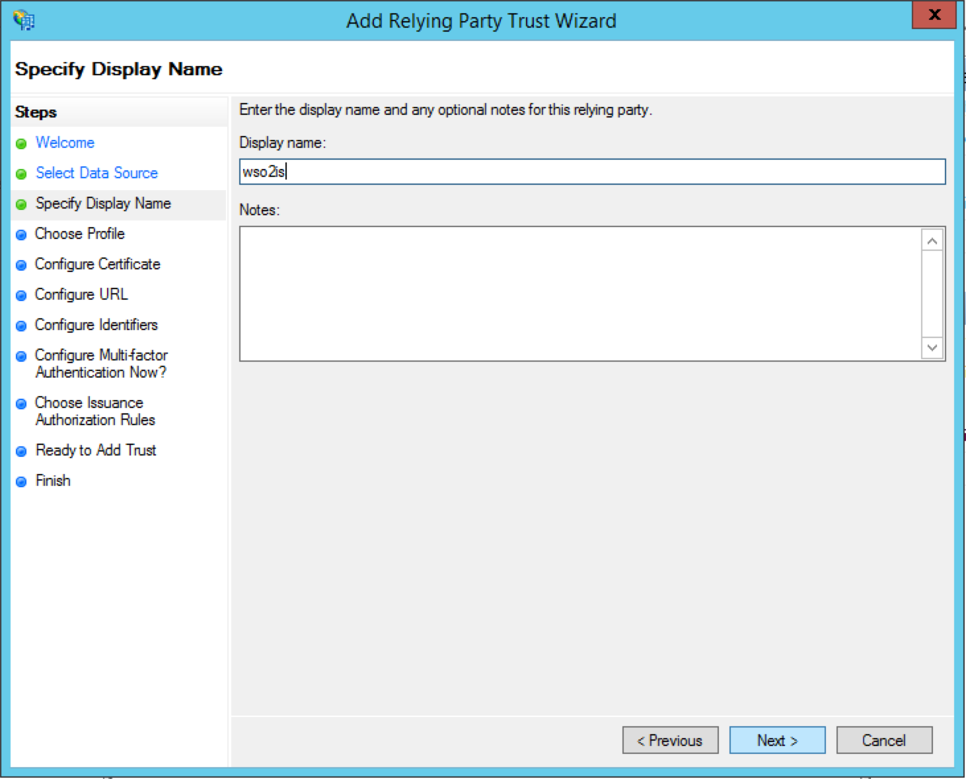

Select AD FS Profile and Click Next.

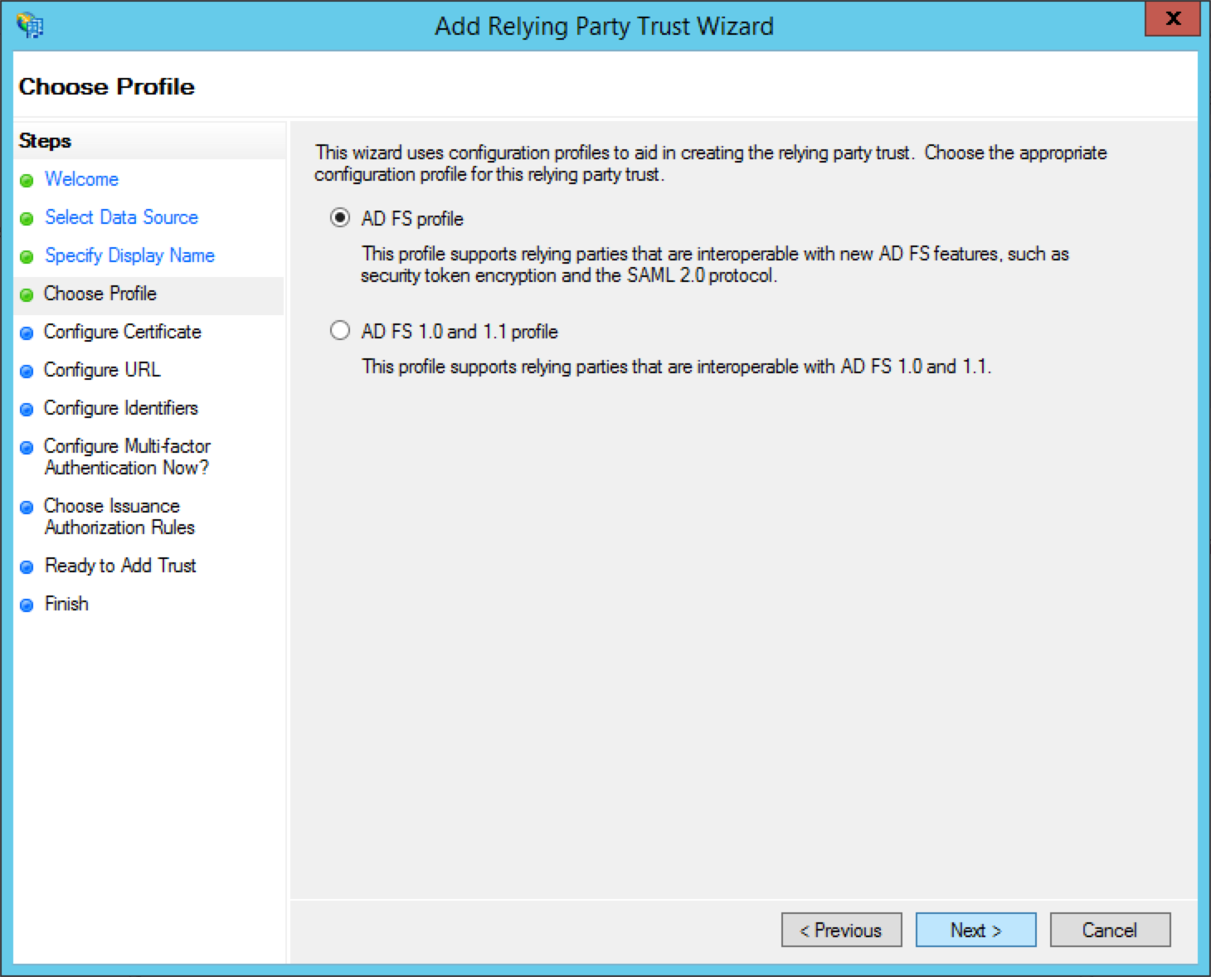

We are not using an encryption certificate so click Next.

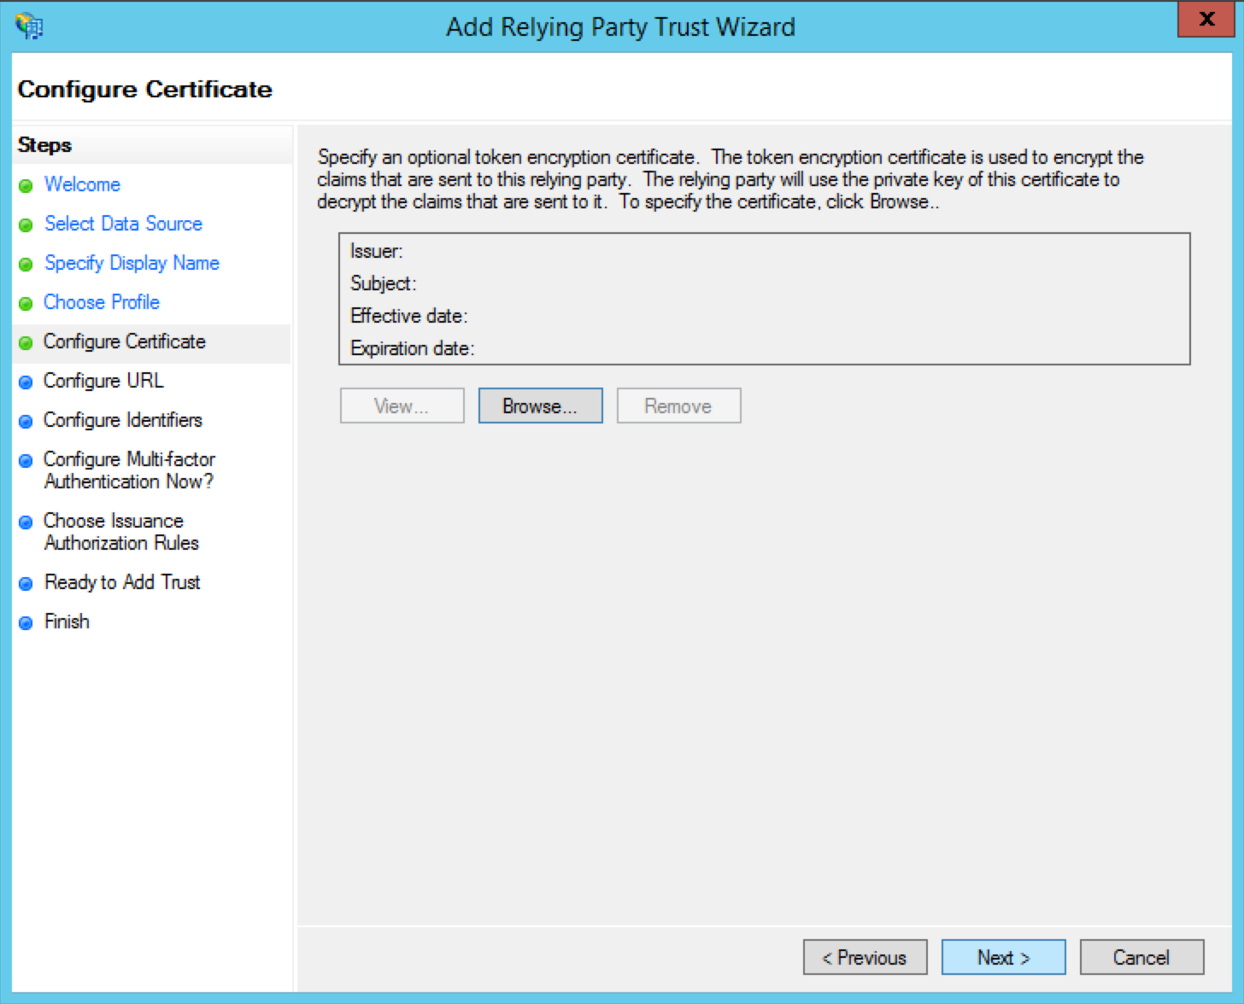

Set the relying party SAML 2.0 SSO service url to the commonauth endpoint.( Ex : <https://apidev.oasys.lk:9443/token>)

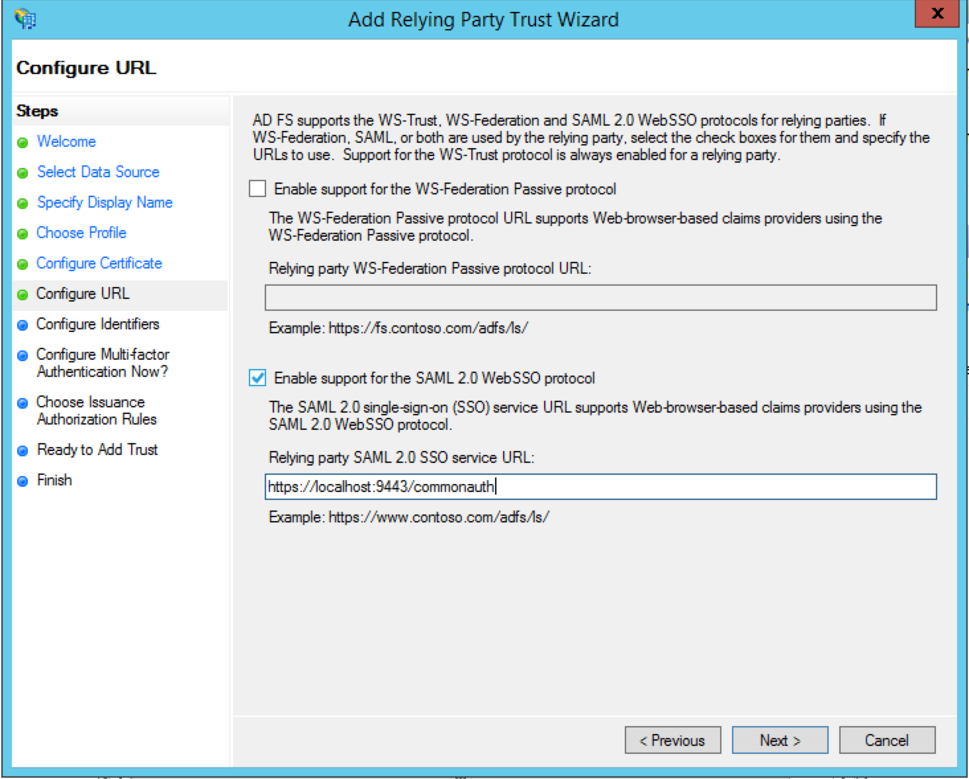

htt

Add the relying party trust identifier and click Next. The value you enter here should be entered in APIM Identity Provider (IdP) settings as well. (ex: wso2km21AzureDev) Setting up the IdP is explained in the next section.

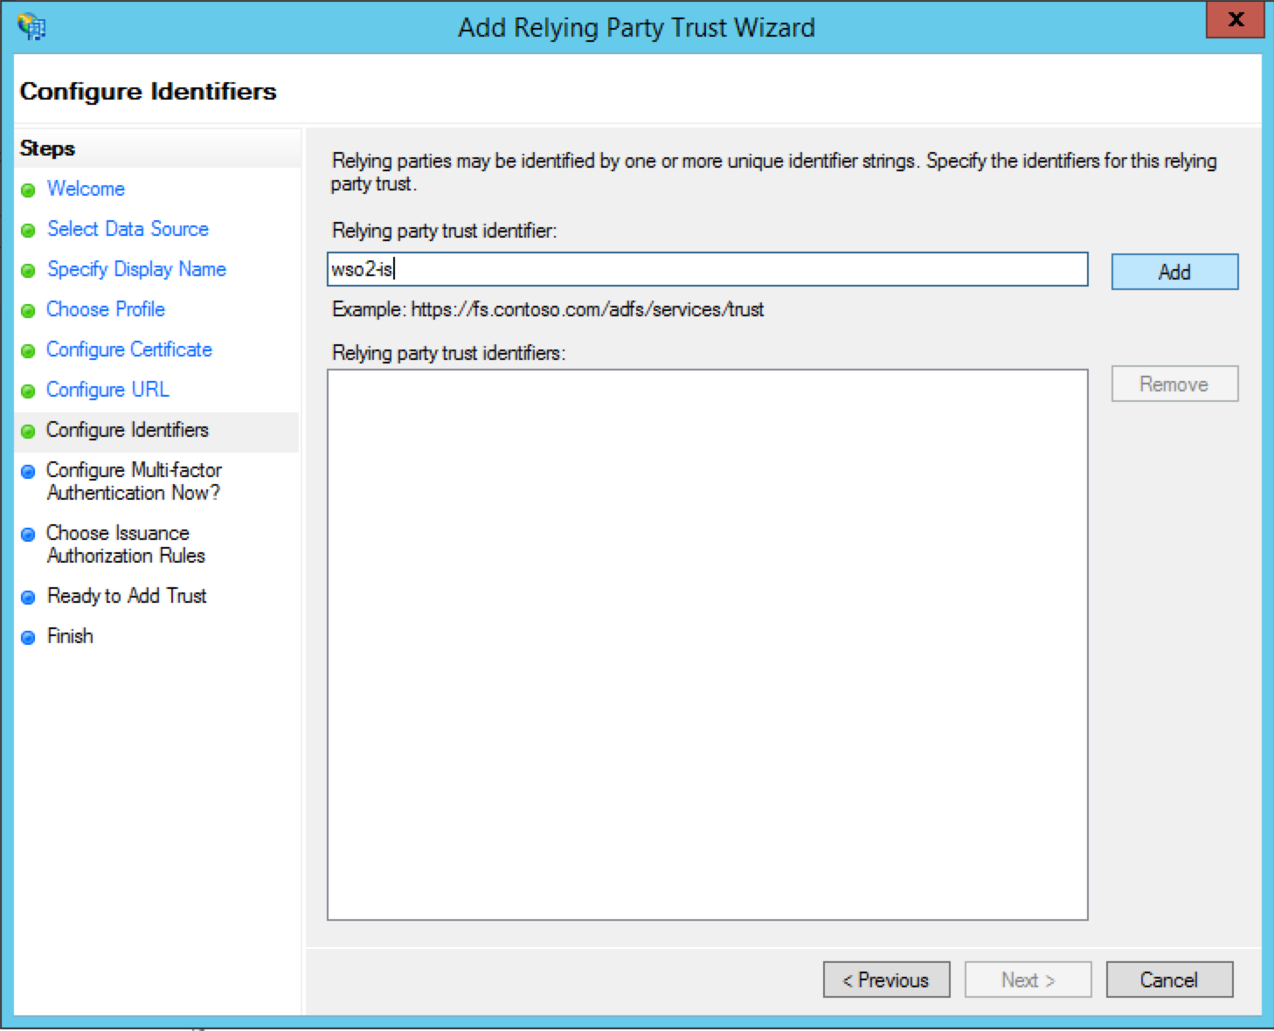

We won’t be configuring multi-factor authentication so click Next.

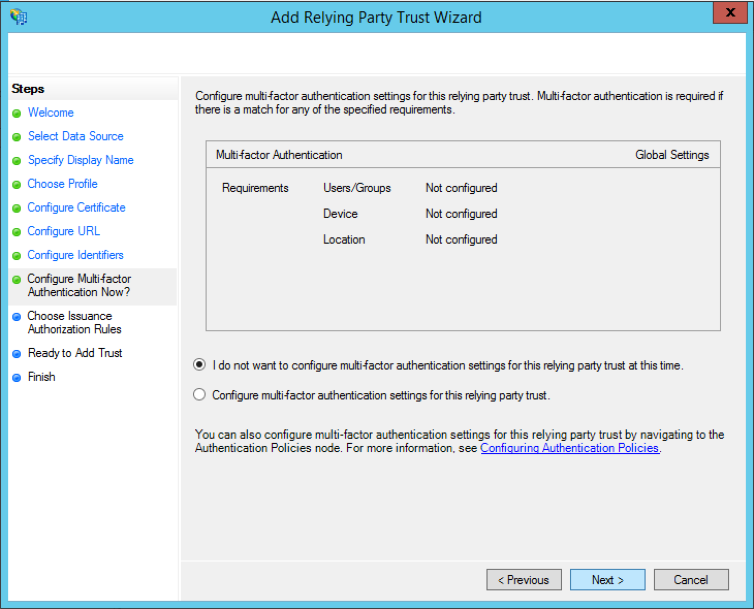

Select Permit all users to access this relying party and click Next.

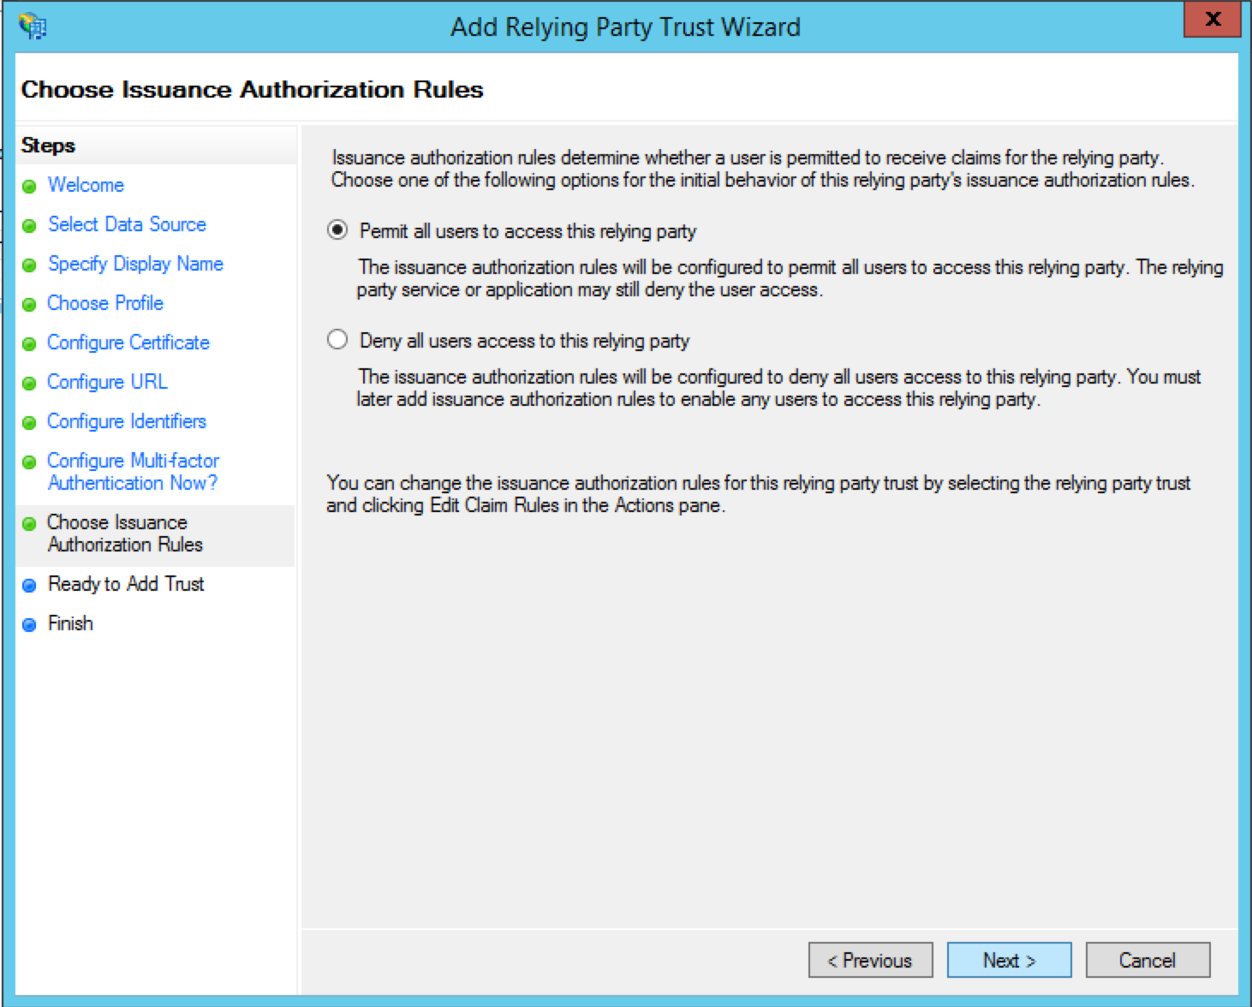

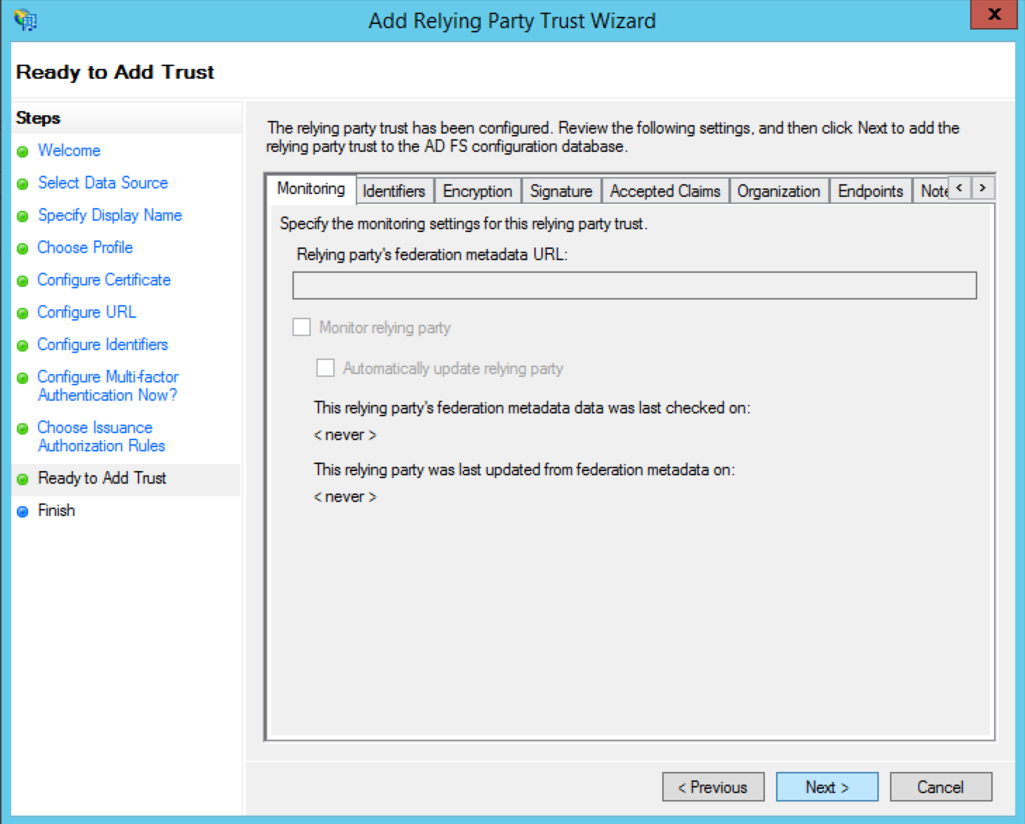Review the Settings & click Next

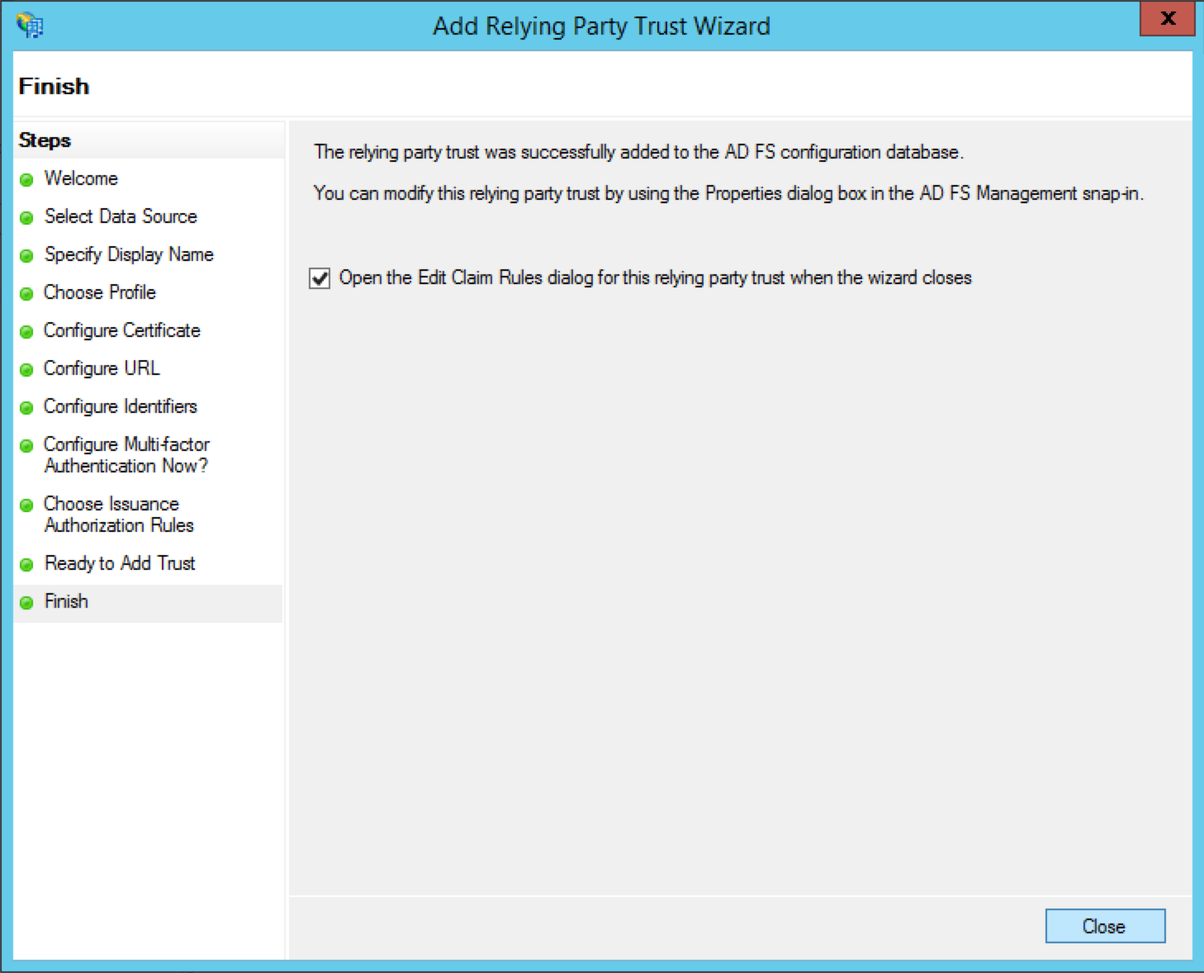Click Close to finish adding the relying party trust. Also let the wizard to open the Claim Rules dialog

In the Edit Claim Rule dialog we will specify which claims to be sent to the relying party.

First click Add Rule…

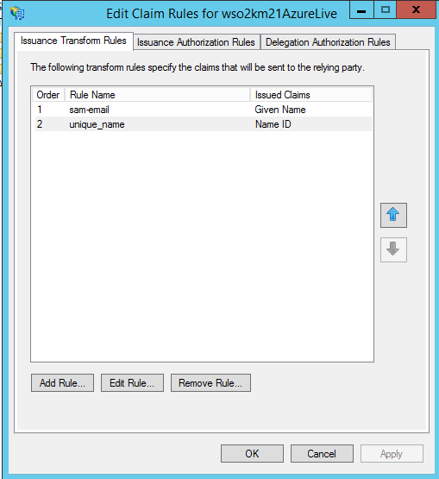

Select Send LDAP Attributes as a claim and click Next.

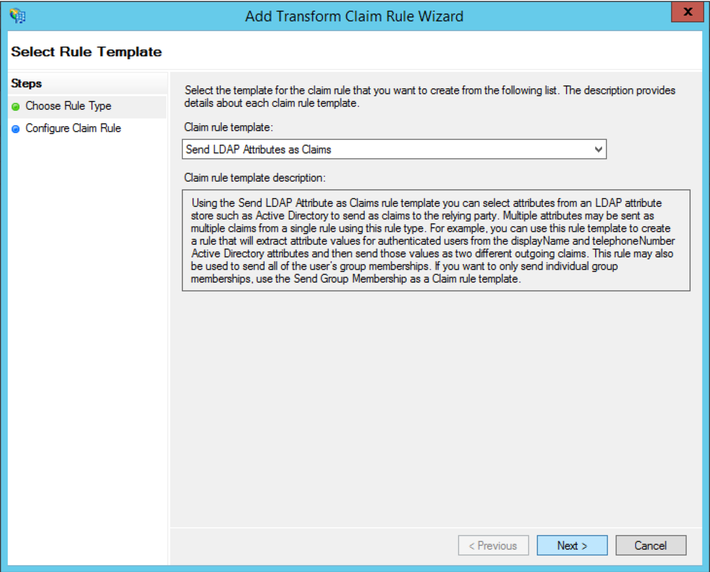

Set a Claim rule name (ex:sam-email) and map **SAM-Account-Name** to **Given Name**. Then click Finish.

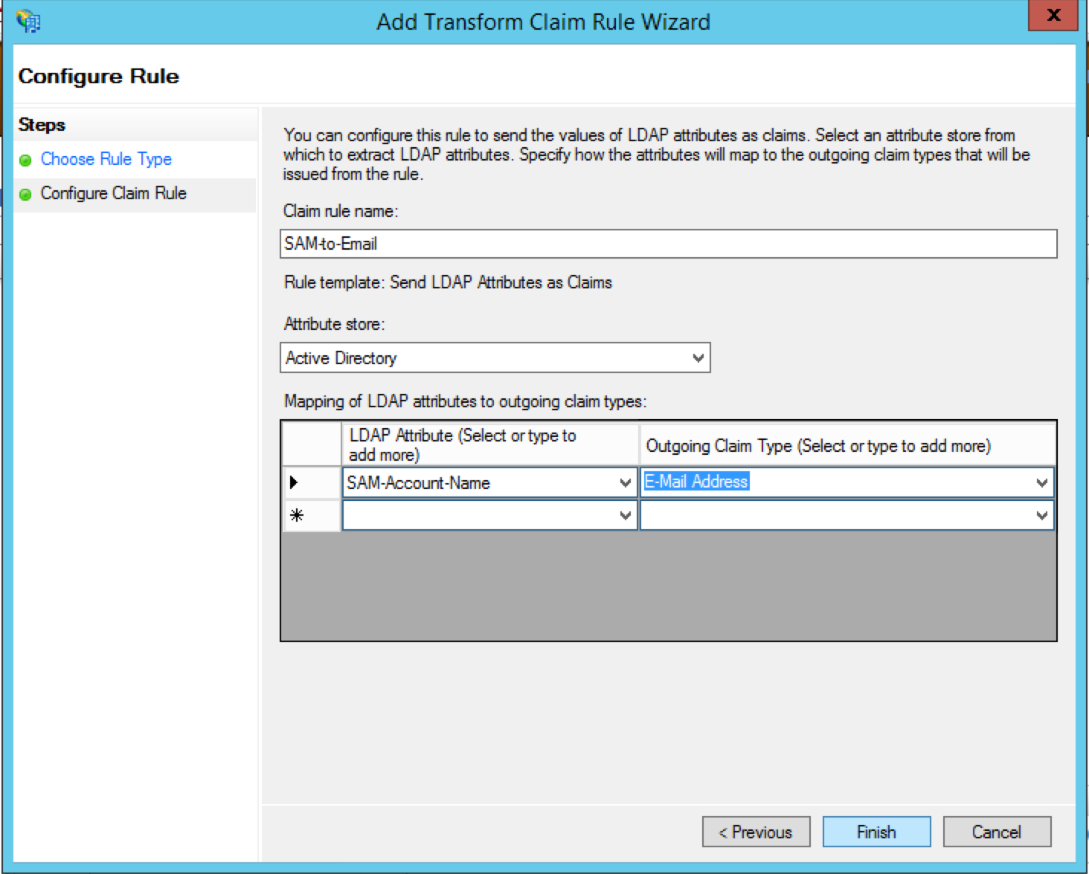

Click Add Rule… again to transform the Given Name claim to NameID claim. Select Transform an Incoming Claim and click Next.

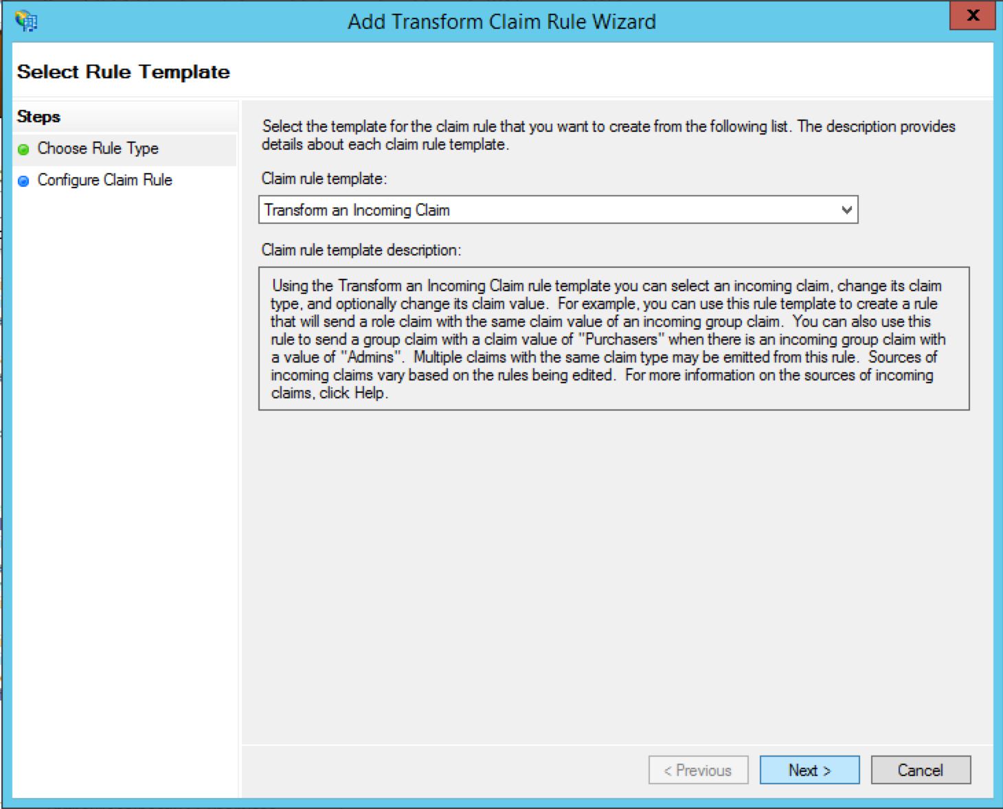

Set the Claim rule name as unique_name . Select the incoming claim type as Given Name and outgoing claim type and ID format as Name ID and Unspecified respectively. Then click Finish.

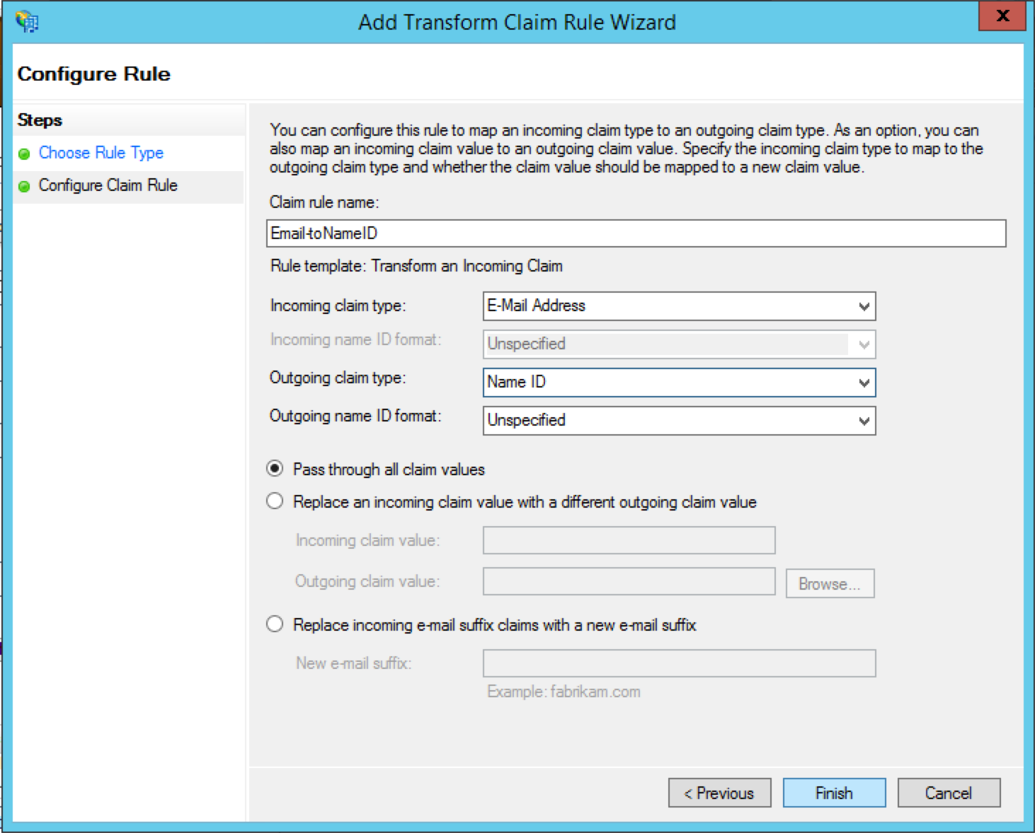

Then apply and close the claim rules dialog

TODO- Change the title of the pic

Then **Apply** and **Close** the Claim Rule Dialog

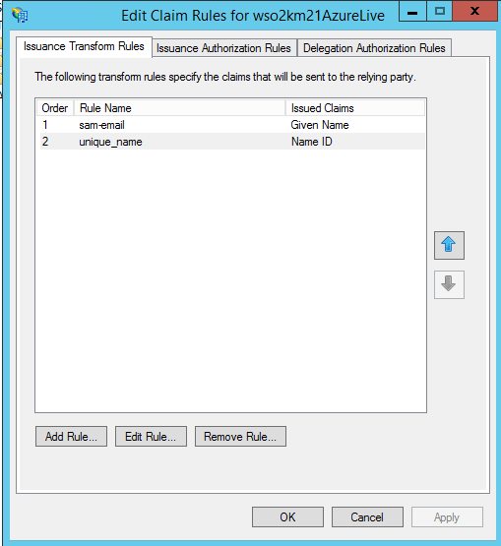

Before we wrap up things in AD FS side, there are few configuration changes needed to be done in Relying Party Trust properties. For that right click on the Relying Party Trust we just created and select Properties.

Go to Signature tab and click Add.

wso2km

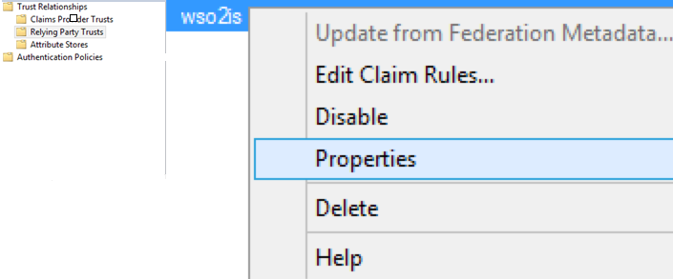

The certificate which should be added here. (APIM Certificate provided by the application owner)

wso2km21AzureLive

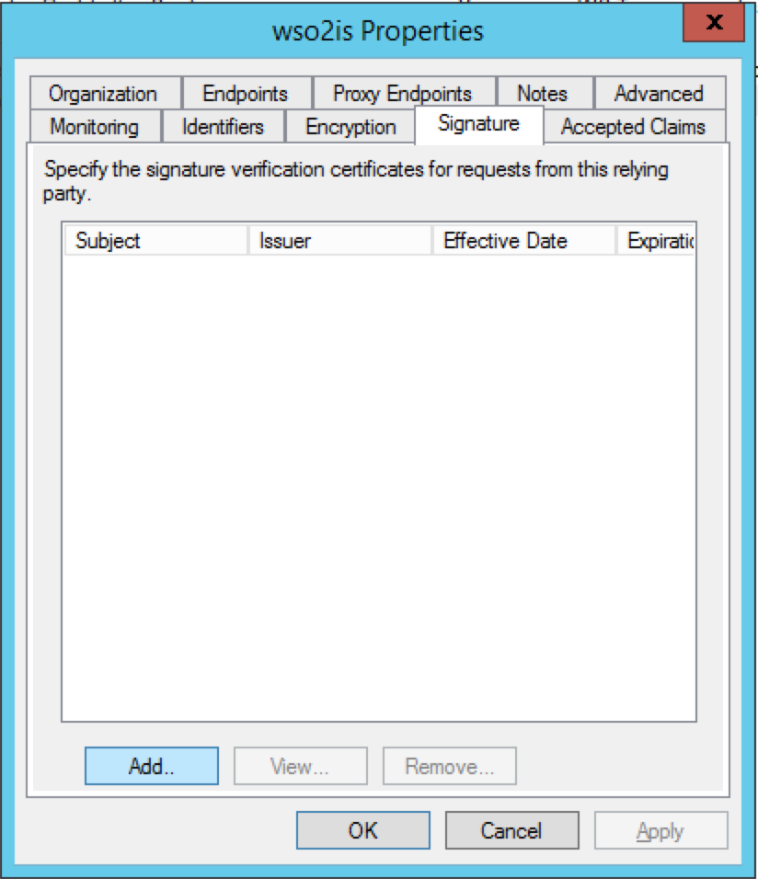

Next move to the Endpoint tab. Here we have to set the SAML logout endpoint. Click Add SAML…

wso2km21AzureLive

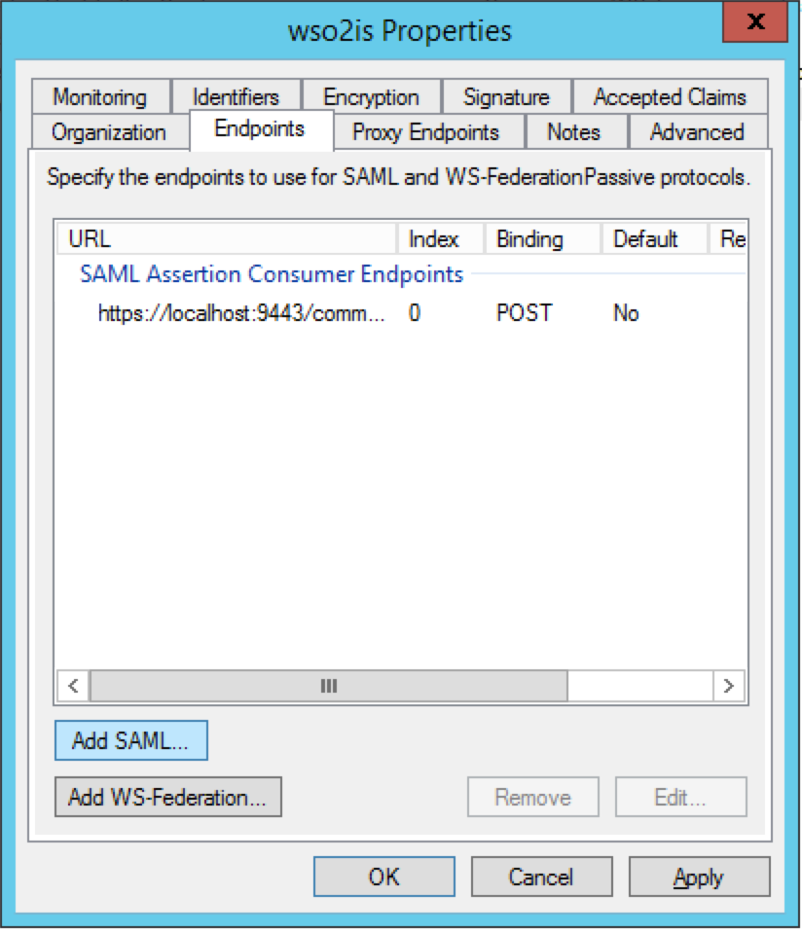

Select Endpoint Type as SAML Logout and the Binding as POST. Set the Trusted URL as https://<AD_FS_server>/adfs/ls  and the Response URL as the /commonauth endpoint of Apim. Once it is done save the property settings of the Relying Party by Clicking OK.

